AP Art Breadth Assignment January 21, 2009
2 D portfolio

“Collage”

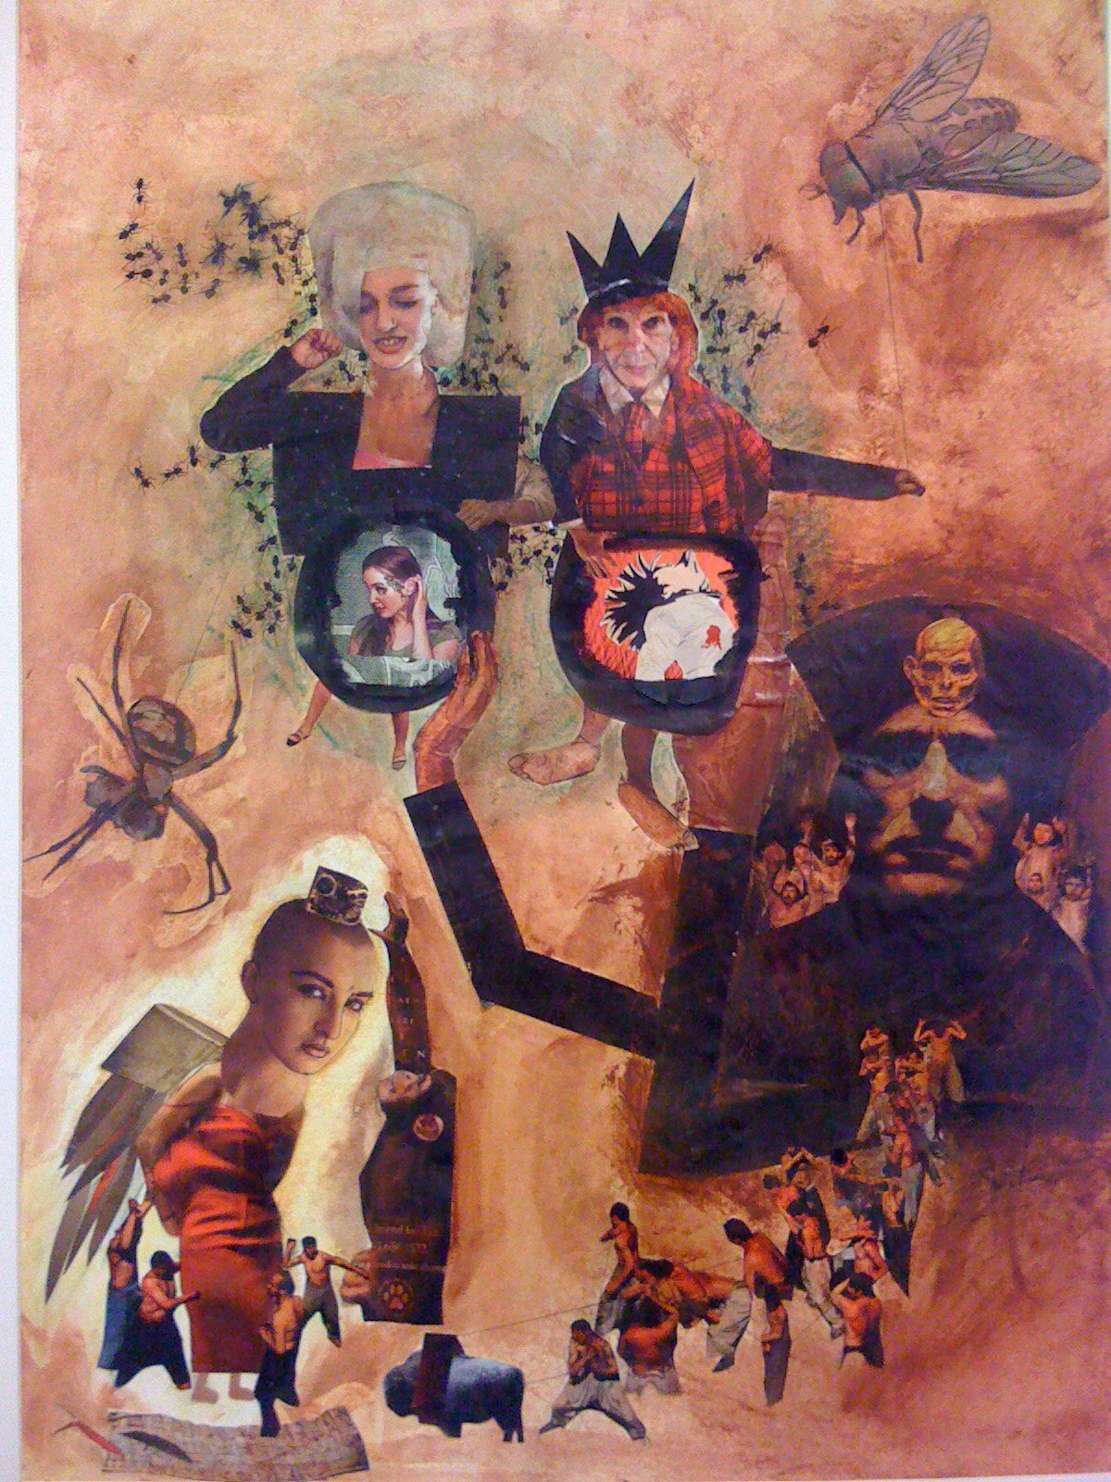

AP 2D example 2008

Objective: To create a piece using collage techniques that demonstrates your understanding of variety, center of interest and movement.

Media:
Ink, watercolor and or acrylic washes
American Masters paper
Images found

Size:
16x20
18x24

Directions:

Research on female contemporary artist , Mutu as well as Romare Beardon
Complete pages in sketchbook on research and ideas
Complete micro labs on how to create value and texture using washes.

Due Date: Monday Feb. 2 for pin up and Critique
See AP Rubric for Grading.

