AP Art Breadth Assignment January 21, 2009

Perspective Birds Eye Point of View

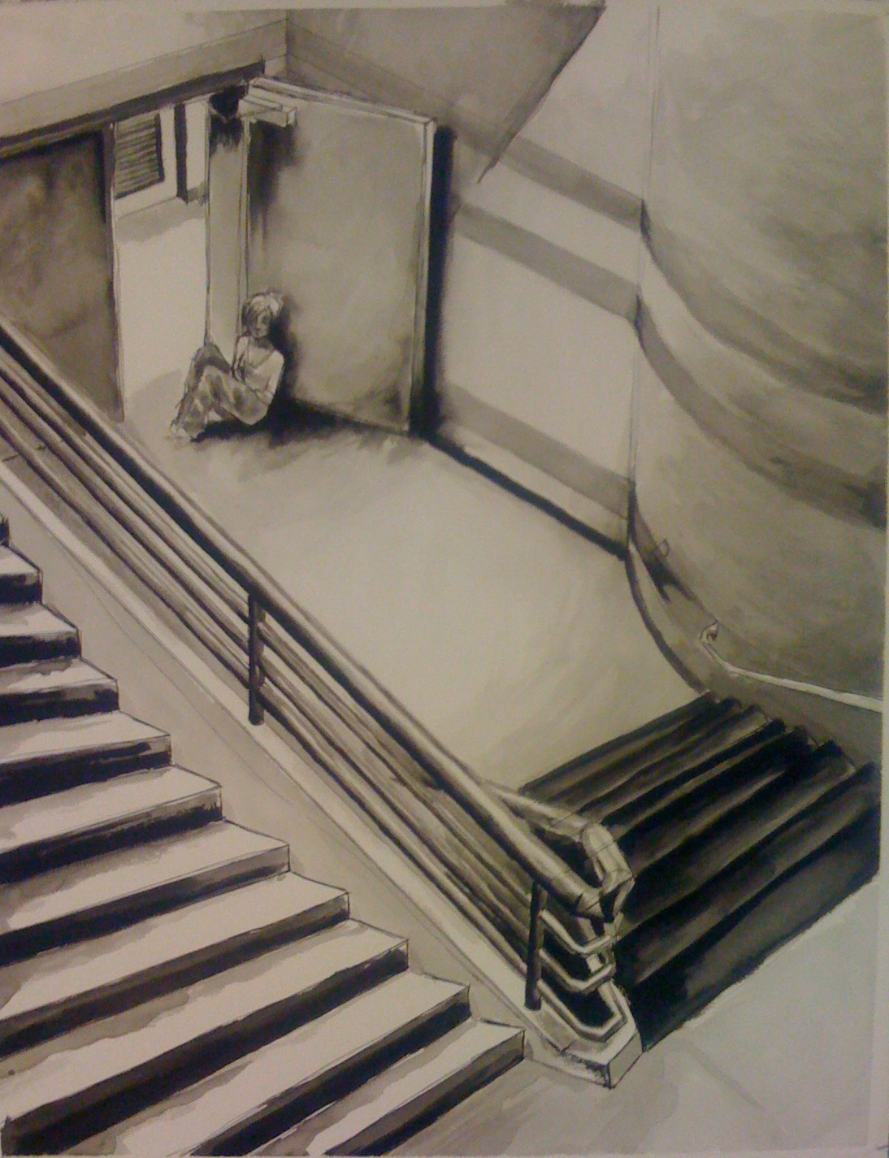
Sara Hemingway Ink wash 2008

Objective: To create a drawing using ink washes that demonstrates your understanding of perspective from a bird’s eye point of view.

Media:
Ink wash
American Masters paper

Size:
16x20
18x24

Directions:
Reading of chapter on perspective
Complete pre-drawings from observation in sketchbook
Complete micro labs on how to create value using ink washes.

Due Date: Monday Feb. 2 for pin up and Critique
See AP Rubric for Grading.

