AP Photography Breadth Assignment January 21, 2009

Panorama

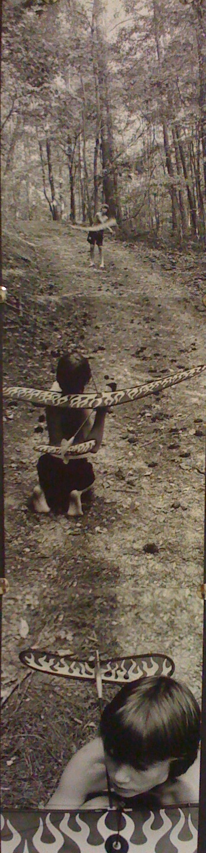 Student example by Milla 2008

Objective: To create an image that is a panorama.

Media:
Trix 400
3 to 5 pieces of photo paper

Size: Any

Directions:

Reading of how to shoot panorama
Complete research and ideas in sketchbook
Shoot film, process and print film

Due Date: Monday Feb. 2 for pin up and Critique
See AP Photo Rubric for Grading.

