**Lesson Title: Contour line inspired by Graffiti**

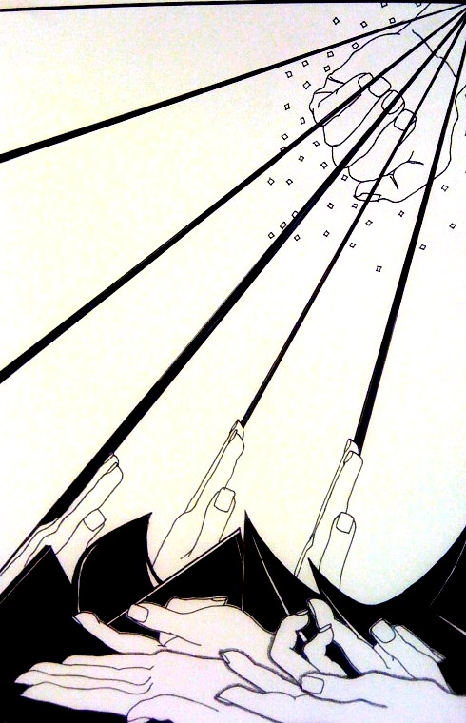

**Teacher: Chappell/Powell**

**Course/Grade Level: Intro**

**Unit#: 1**

**FCS Standards and Elements:** *S1-Understanding and applying media techniques and processes.*

*S11- Using knowledge and functions, S111- Choosing and evaluating using a range of subject matter., S1V- Choosing the visual arts in relation to history and culture, SV- Reflecting upon and assessing the characteristics and merits of their work and the work of others.*

**Overarching Goals of this Lesson:**

***Essential questions****: What is contour line? How can you incorporate the elements and principles in a drawing inspired by graffiti art? What is graffiti art and why is it a valid art form?*

***Objective****: Create a finished contour line drawing with the following:*

* *A composition with that uses at least 5 contour line drawings of hands*
* *Creates perspective between objects*
* *Uses influences from graffiti research*
* *Uses pattern throughout to balance negative space*

**Vocabulary-** *Contour line, accented line, contrast, emphasis, repetition, shape, composition graffiti, design.*

|  |  |
| --- | --- |
| **Materials:** |  |
| *White drawing paper cut to 11x14*  *Pencils*  *Sharpie markers or black felt tip pens* |  |

**Procedure:**

**Mini Lab:** Contour line practice

Patterns page

1. Research professional graffiti artists; create a page of practice on contour line drawings of hand; create a page filled with different patterns.
2. Brainstorm ideas and compositions by creating at least 4 thumbnail sketches.
3. Begin by choosing one thumbnail sketch to use as your final work – redraw to confirm all choices before beginning actual work.
4. Begin final work by drawing in pencil first
5. Once your work is totally drawn out in pencil, use thin and thick sharpies to trace back over lines and patterns
6. Erase all pencil lines showing and turn in.

**Evaluation/Assessment:**

*Students will participate in a group critique*

*Students will fill out a rubric for assignment*