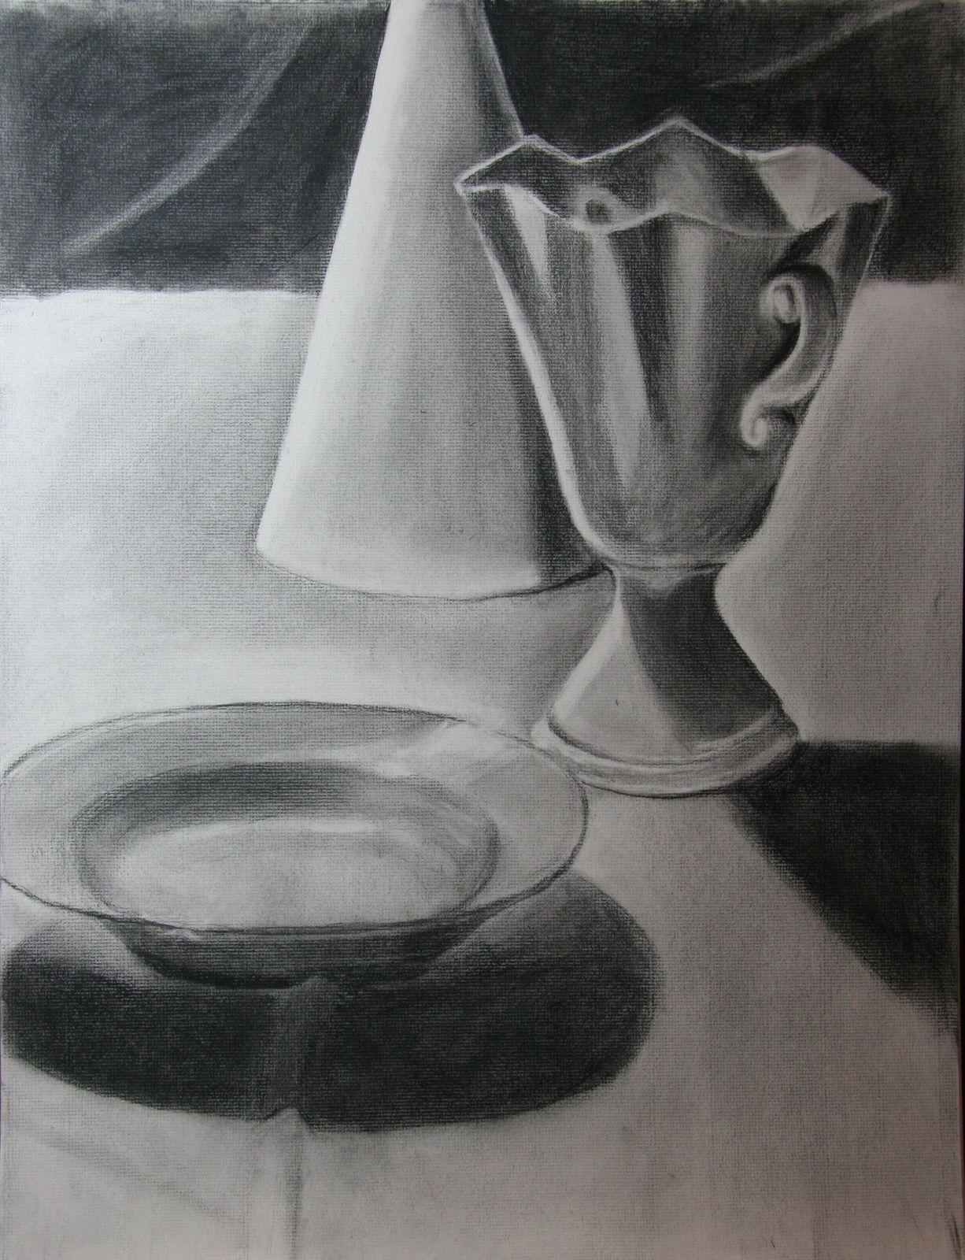

Drawing and Painting 1
Homework Due: Monday Sept. 29

Using the paper provided to you please draw and
shade three simple white objects from
observation.

Directions:
1. Select three simple white objects from your
home.
2. Arrange the objects in an interesting comp.
3. Make sure your objects are on a simple
piece of white fabric, paper or paper towel.
Also make sure you set a white background.
4.Set up a light source for your still life,
you may want to use a small desk light or flash
light to illuminate your still life.
5. Thinking about composition,
Begin by lightly drawing out your still life
using a number 2 pencil.
6. Indicate your tonal shapes, shade still life
from observation. Student drawing artist unknown.

Remember and use the rules of good comp.
Touch two sides of the paper with the objects, the
Negative space should be as interesting as the positive space.

Graphite Drawing of small still life homework
Grading Rubric

Criteria | Superior Achievement  100 to 90 | Satisfactory Achievement  89 to 80 | Needs Improvement  79 to 70 | Unsatisfactory  69 to 0
- Drawing is accurate and realistic.  - Proportions of objects are correct and accurate | There is great evidence of drawing directly from the subject with close observation.  Objects appear realistic due to the parts being drawn with close attention to proportion and relationship of one part to another | Most shapes are drawn correctly with the appearance of observation from the subject.  Most proportions and relationships or one part to another indicate drawing from observation of the subject. | Many of the contours are not accurate and seem to be made up and drawing is not in proportion  Attempts are made to draw the subject but without looking and drawing directly from the subject. | Lines are sketchy and are made with little relationship to the subject.  Drawing appears unrealistic with parts shaped incorrectly and relationship of one part to another is incorrect.  Drawing is not finished or not turned in on time.
Shading to Show Form -  - Shadows and Highlights show consistent light direction  objects appears to be 3dimensional by gradations of value.  Strong use of contrast is evident | There is clear indication of form created by tones which curve across the contour of the surface.  The objects show surface contour which appears 3 dimensional.  There are no value breaks and drawing has a sense of contrast | Some values are used to show form and some follow the contours of the surface of the object.  Some highlights and shadows show consistent light direction.  Objects appear to be more than a flat shape.  There are a few breaks in value and gradation but drawing is very grey in tone and lacks contrast. | Lines are mainly used as outlines and student does not understand value to create form.  No gradation of value is evident; values are flat and are not consistent in light direction.  Values are flat and muddy. | Bag appears flat with outlines and no use and understanding of value to create form.  Work is not complete nor turned in on time.  Values are very muddy.
Composition and creativity  *Composition is interesting  * Compositional techniques have been used in drawing.  * Composition is creative and clearly shows an idea and thought. | ¾ positive to ¼ negative is used, some of the image may run off the page. Nothing is centered.  The composition and idea is well thought out through evidence of planning.  Composition is very interesting and creative. | Some compositional techniques are being used.  The idea is not that well thought out.  Composition is not that interesting. | Very few compositional techniques are being used, subject is centered.  The idea was not thought about and image was just taken to get it done.  The composition is not interesting.  Composition is not that interesting and student has made no regard to the rules for composition | No compositional techniques have been used and image is centered.  Composition is not complete.  Student does not understand composition.  Too much negative space is not being used in comp.
Craftsmanship –  - Paper is clear of random smudges and marks  - Lines drawn incorrectly are redrawn in correct location and correct size. They are not erased. | Paper is spotless and clear of blemishes  Craftsmanship is clearly evident in this work. | Paper is mostly clear and has very few random marks. | Paper is crumpled and has some smudges and random lines. | Work is crumpled and has many wrinkles, tears and smudges.  Work is not completed nor turned in on time.

