Course: | Printmaking 1 |  | 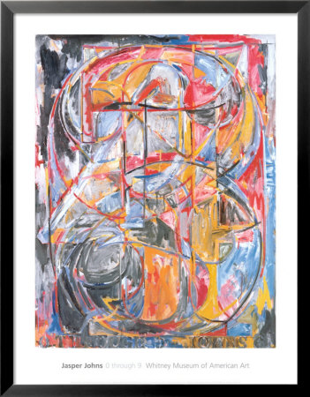
Unit of Study: | Monoprints
Lesson Title: | In The Style of /Inspired by………
Project Pacing: | 2 weeks
Overarching Essential Question: |  | How can I create a mono print inspired by or in the style of _______artist?
Georgia Performance Standards Addressed in this Project:
Meaning & Creative Thinking:
VAHSVAMC.1 Engages in the creative process, imagines new ideas by using mental and visual imagery, conceptualizes these ideas by using artistic language and contextual understandings in assessing learning, and develops a personal artistic voice that gives unique form to these concepts.
VAHSVAMC.3 Cultivates critical thinking and logical argumentation in aesthetics.
VAHSPRMC.2 Finds and solves problems though open-ended inquiry, the consideration of multiple options, weighing consequences, and assessing results.
Contextual Understanding:
VAHSVACU.2 Demonstrates an understanding of how art history impacts the creative process of art making.
Production
VAHSVAPR.1 Uses formal qualities of art (elements and principles) to create unified composition and communicate meaning
VAHSVAPR.2 Understands and applies media, techniques, and processes in drawing
VAHSVAPR.3 Understands and applies media, techniques, and processes in color / painting
VAHSVAPR.5 Creates artwork reflecting a range of concepts, ideas, and subject matter.
VAHSVAPR.6 Keeps a visual/verbal sketchbook journal, consistently throughout the course, to collect, develop, and preserve ideas in order to produce works of art around themes of personal meaning.
VAHSVAPR.7 Develops a portfolio of artwork for the course.
Assessment & Reflection:
VAHSVAAR.1 Makes written and oral critiques of own works of art.
VAHSVAAR.2 Critiques artwork of others individually and in group settings.
Connections:
VAHSVAC.1 Applies information from other disciplines to enhance the understanding and production of artworks.
VAHSVAC.2 Develops 21st century life and work skills and habits of mind for success through the study and production of art.
VVJ Assignments:
- Create a two page spread on Juan Quick-to-see as well as finding other printmakers you find interesting
- Working drawings using references and or other sources
Mini-Labs:
Experimentation with 6 different mono print processes

Materials:
Water based printmaking inks, brayers, paper, bloating paper, plexi glass for plates, q-tips, paint brushes, hand press, found materials.
Studio Project:
- Read chapter on Mono prints in book. Take notes and quiz.
- Mini-Lab: Demonstration of techniques
- Mini-Lab: 5 class days of experimentation creating 6 different prints all labeled with technique
- Introduction of lesson. Work in sketchbook to create ideas based on artists given.
- Create 5 prints based on or inspired by one of the following artists.
Jasper Johns, Juan Quick-to-See, Jean Micheal Basquiat, Rick Bartow, Howard Warsaw- Red Man, Wayne Thiebaud.

Assessment:
Rubric

