Name ______________________________________ Period _____ Date ________________________
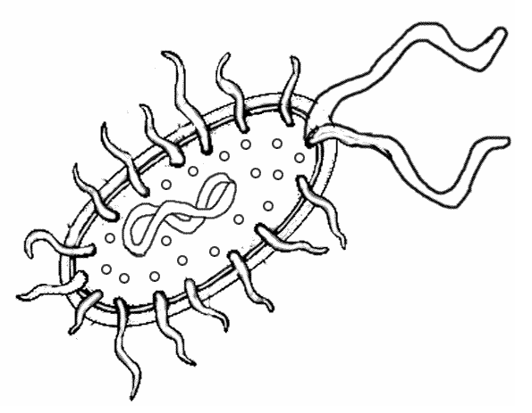
Prokaryote Coloring and Review
Bacteria have a very simple cell design. Most of them have a thick outer covering called the cell wall. On the picture, color the cell wall purple (it’s the outermost layer). Just within the cell wall is the cell membrane. Color the cell membrane pink. Along the surface of the bacteria cell, you might encounter structures called pilus, whose job is to help the bacteria stick to surfaces. Color all the pilus light green. Bacteria might also need to move around in their environment, so they can have structures called flagella, which resemble tails. Find the two flagella pictured and color them dark green. The watery interior of the cell is called cytoplasm, and it has the texture of jello. Color the cytoplasm light blue. Sprinkled throughout the cell are small roundish structures called ribosomes. Ribosomes make proteins for the cell. Color all of the ribosomes red. Every prokaryote cell has DNA floating within the cytoplasm, which usually looks like a twisted strand of spaghetti. DNA contains the instructions for the cell, basically it is the control center. Find the DNA and color it yellow.
Read 18.4, 18.5 and 18.6. Then answer the following questions.
- Single celled organisms that lack membrane-bound organelles are called ______________________ because they lack a true nucleus.
- __________________________________ are found in extremely harsh environments.
- What are the three shapes that bacteria are classified?
_______________________ _______________________ _______________________
- What shape does Staphylococci have? ____________________
- Why are bacteria and archaea classified into different domains? _____________________________________________________________________________________________________________________________________________________________________________________________________________________________________________________________________
- The single chromosome mass found in bacteria is called a ______________________ .
- Small extra loops of DNA found in a bacterium are called _____________________.
- Prokaryotes will take up foreign DNA. How is this characteristic used in genetic engineering? ______________________________________________________________________________________________________________________________________________________________________________
- Scientists estimate that only 1 percent of prokaryotes can be grown in the lab. What does this suggest about our knowledge of bacteria and archaea? ______________________________________________________________________________________________________________________________________________________________________________
- Bacteria that require oxygen to live are called _________________________________.
- Bacteria that would die in the presence of oxygen are called __________________________.
- Bacteria that can live with or without oxygen are called ______________________________.
- A gram-positive bacterium stains the color ______________________.
- A gram-negative bacterium stains the color ______________________.
- Gram- ________________________________ bacteria are more resistant to antibiotics.
- The bacterial cell wall is made of a protein-carbohydrate compound called ________________________.
- How can antibiotics stop bacterial infections? ______________________________________________________________________________________________________________________________________________________________________________
- Why are antibiotics not effective against viruses? ______________________________________________________________________________
- What is antibiotic resistance and how does it occur? ______________________________________________________________________________________________________________________________________________________________________________
- Evolution is often thought of as taking thousands, or even millions, of years to occur. What are two reasons that antibiotic resistance has been able to evolve in bacteria so quickly? ______________________________________________________________________________________________________________________________________________________________________________
- ______________________________ bacteria have the ability to produce their own food.
- ______________________________ are bacteria that feed on dead organisms.
- While the photosynthetic bacteria are similar to plants, these bacteria do not have ____________________. Photosynthetic bacteria are also called ___________________ .
- _________________________ can get their energy from inorganic substances, such as sulfur or nitrogen.
- _________________________ get both their energy and their nutrients from other organisms.
- Bacteria lack mitochondria so their _________________________ is the site of cellular respiration.
- Some bacteria have ____________________ that help them to move, others rely on air or fluid currents.
- The vast majority of bacteria reproduce asexually by a process called _____________________ . ______________________________.
- During _______________________, a donor bacterium transfers genetic material to a recipient bacterium.
- Why are mutations and conjugation important for natural selection in prokaryotes? ______________________________________________________________________________________________________________________________________________________________________________
- Bacteria in your mouth convert foods containing sugar and starch into acids that can then cause cavities in your teeth. These bacteria will be present even if you brush your teeth, floss, or use mouthwash. So why are these hygiene habits so important? ______________________________________________________________________________________________________________________________________________________________________________
- Describe two ways bacteria provide nutrients to humans. ______________________________________________________________________________________________________________________________________________________________________________
- What are the two roles prokaryotes play in the cycling of element in an ecosystem? ______________________________________________________________________________________________________________________________________________________________________________
- How do prokaryotes lend stability to an ecosystem? ______________________________________________________________________________________________________________________________________________________________________________
- Prokaryotes in cow intestines produce more methane if the cow is fed a diet high in grains rather than grass. Some scientists propose that overfeeding grain to cows contributes to global warming. How did these scientists arrive at this hypothesis? ______________________________________________________________________________________________________________________________________________________________________________
- Pesticide resistance occurs in much the same way as antibiotic resistance. How could we apply what we have learned about antibiotic resistance to how pesticides are used in the environment? _____________________________________________________________________________________________________________________________________________________________________________________________________________________________________________________________________

