Age of Reason Follow-Along Guide
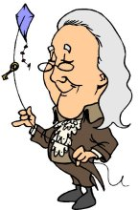

1) What are the dates for the Age of Reason?

2) What is the Age of Reason?

3) How did enlightenment thinkers differ from scientists?

4) What famous war occurred during this period?

5) How did enlightenment thinkers differ from the Puritans?

6) Explain the concept of Deism and Tabula Rasa.

7) Explain:

-Rhetoric

-Reason

-Logic

-Socratic Method

8) Explain the significance of the Declaration of Independence. Who played a key role in its creation?

9) List 3 literary characteristics of the Age of Reason.

10) Indentify and describe the key writers during this period:

