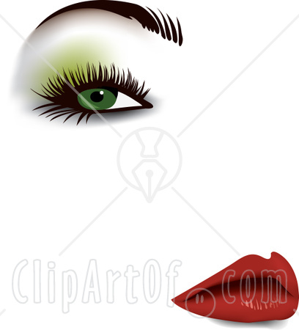 Beauty and Culture PowerPoint Notes

1) What is Beauty?

2) What is a corset? What are many of the problems women faced from corsets?

3) Explain the concept of Chinese Foot Binding? Why did women do it? At what age did it start?

4) Identify: Golden Lotus

5) What are the beauty size ideals in many African cultures?

6) How does the Western world view fat?

7) Explain the correlation between weight and economic class? Why is this the case?

8) How do the Padaung women of SE Asia express their beauty?

9) Identify: Lip Plates

10) What happens when cultural ideologies and institutions change?

11) Identify: Cultural Ethnocentrism

