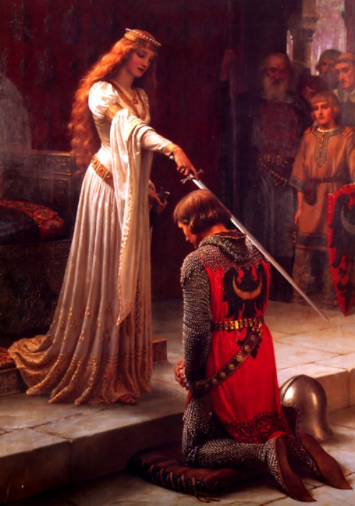
CHIVALRY AND COURTLY LOVE PARTNER ACTIVITY

DIRECTIONS:
WITH YOUR PARTNER, READ THE HANDOUT ON THE ELEMENTS OF CHILVARY AND COURTLY LOVE

CHOOSE EITHER CHILVARY OR COURTLY LOVE

YOU WILL WRITE A LIST OF 10 OFFICIAL COMMANDMENTS (WRITTEN IN MODERN LANGUAGE/SLANG) IN REGUARDS TO YOUR CHOICE

