College Application Portfolio
Due Friday, Sept. 2nd 2011
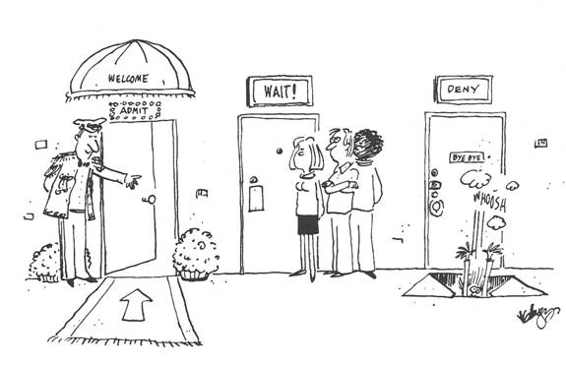
Part 1: Write a well written response to the college application essay question of your choice.
- Your essay should meet the specifications of the essay (word count, topic, etc.). You will need to include a copy of the specific question you are responding to with your essay.
- It should have an inviting introduction (hook) and a strong conclusion which synthesizes, rather than restates, the points raised in your essay.
- Your final essay should include your rough draft.
- It must be typed, and double spaced.
- It should be free of grammatical and spelling errors.
Part 2: Create a resume based on your high school experiences and accomplishments
- It should be free of grammatical and spelling errors.
- It should be typed in Times New Roman OR Ariel font
- Must contain all seven elements of a HS resume (see example)
Part 3: The College Memento- This is a souvenir of sorts and may include any ONE of the following:
- Original News/Magazine Article
- Post Card
- Map of the college
- Top 10 List (ex: what every Freshman should know)
- Pro-con List (minimum 10 items)
- Collection of quotations by well-known/ successful alumni (minimum 10 items)

Timeline:
- First Draft for Peer Editing due Friday, August 26th
- Final Draft due Friday, Sept. 2nd

FYI
- You must turn in drafts and prewriting along with a copy of the question.
- This counts as a major writing grade.
- You will need to turn in both a hard copy AND submit in into Turnitin.com. Failure to turn it in through turnitin.com will result in a 10 point deduction from your grade.
- Late papers will lose twenty points a day and will not be accepted after Friday, September 10th
- Papers that are not typed, 12pt Times New Roman font and double spaced will lose up to 10 points.
- Also, the word count MUST be printed at the bottom, or you will lose up to 10 points.

