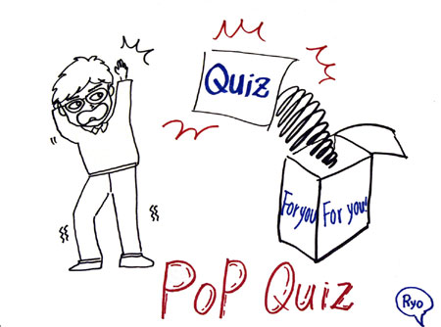Name_____________

Pop quiz Meaning:
A short test that is given in class without any warning beforehand.
A pop quiz is a quiz (a short test) that your teacher gives you without any advance notice to check if you have been paying attention .

Example: Ms. Hayes, an English teacher, is famous for giving her students a lot of pop quizzes.

1) How many stories high is Tom?

2) What flies out of Tom’s window? *include the color!

3) Where does Tom’s wife go?

4) What happens when Tom gets to the window?

5) Predict Tom’s fate at the end of the story.

