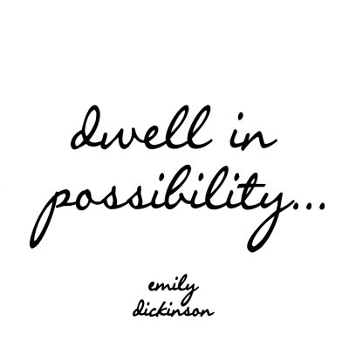
PowerPoint Follow-Along Guide

1) What was Dickinson’s religious background?

2) How did Dickinson feel about “home”? *** hint, use her exact quote

3) How did Dickinson feel about the religious views she was raised with?

4) What were some of Dickinson’s hobbies?

5) How did Dickinson interact with her friends and family while she was in isolation?

6) Who were her three main literary influences? Which of these writers have we read two poems by?

7) How did Dickinson feel about Emerson and Thoreau?

[Turn to the Back]

8) What were some of her “Other Influences”?

9) What is the name of Dickinson’s writing style?

10) What rhyme scheme does she typically use?

11) Define Consonance and Assonance? *hint- this is not on the PPT… you must listen to ME!

12) List five themes used in Dickinson’s poetry.

13) Describe Dickinson’s home.

