Pre-World War II
European Jewish Family Life Photo Project
This counts as ½ of a major project grade (50 points)
Due: Thursday, December 2nd
Focus of this project: Art Spiegelman’s Maus I tells the story of Art’s father Vladek, and his life before, during, and after the Holocaust. By focusing on the life story of a single person, Spiegelman puts a very human face on the overwhelming statistics of the Holocaust. The result is that the reader can better appreciate what Jewish family life was like in Europe before World War II and how it was altered when Jewish communities came under Nazi rule during the war. In order to better understand what Jewish cultural and communal life was like in Europe before World War II, you will be finding photographs from that time period and analyzing them.
STEP #1, Photo Collection and Note-taking
Research and save three photos that reflect Jewish family life prior to the Nazi invasion of that country using the United States Holocaust Memorial Museum’s Web site at:
http://www.ushmm.org/research/collections/photo/
Search the collection of thousands of photos using key words related to family life (useful terms include: siblings, families, birthday, beach, picnic, holiday, etc.). Once you have found a photo you would like to use, right click on it, copy it, and paste it into a new word document. Then return to the photo on the Web site, and copy and paste the date and locale to the word document with the photo (do NOT copy and paste any other information, including the captions). Next, take notes from the web site that include information about the subject’s life before the war, what happened to the subject during the war, and (if applicable) after the war.
Guidelines for choosing photos:
- People must be in the photo.
- The photo cannot be one that’s classified as a studio portrait.
- The photo must include the date and place that the photo was taken.
- The date of the photo must be before the war reached that country (Germany invaded Poland in 1939).\
STEP #2, Photo Analysis: Write captions for both photos using example on the back of this handout as a model. Your caption must include information about what happened to the subject during the war, and (if applicable) after the war. (4-6 sentences)
STEP #3: Now write an organized, well-thought-out and complete response that explains how the photo(s) you chose show the similarities between you, your family, or your community and those in the researched photos. You must describe how the photograph relates to the graphic novel, Maus. (6-8 sentences)
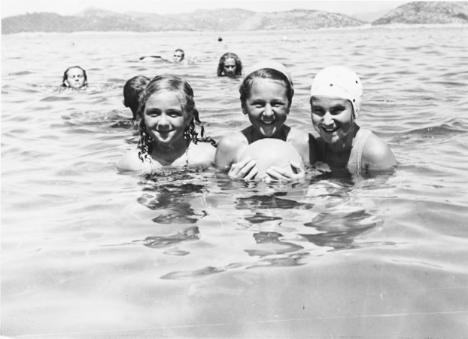
Caption with date/locale/information about subject [what happened to the subject(s) during and (if applicable) after the war]:
Pictured are members of the Spitzer family on vacation in 1934 on the island of Lopud in the Adriatic Sea, where during WWII they would be imprisoned in an Italian internment camp. Happily, at the end of the war the girls and their mother were reunited with their father and the family moved to Israel in 1948.
Personal connection [why you chose this and how it relates to you and/or your family life]:
I chose this photo because the girls are about the same age as my cousins and their faces are full of joy and life, just like my cousins’ faces is whenever they get to swim in the ocean. When I read their family’s story I was incredibly relieved to learn that the girls and their parents survived the Holocaust. For me as a teacher, the saddest and scariest part of the Holocaust is realizing how many children never became adults. The Spitzer girls, Leah and Miriam, were among the lucky ones who were able look back at a photo like this one and know that everyone in it survived. As far as the connection to Maus, Vladek’s and Anja’s lives were so joyful before they had to suffer through the Holocaust. This picture shows just how quickly life can change.

