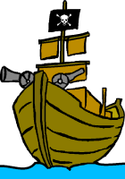Exploration Narrative Details Chart: Complete for each selection that we read.

Narrative | Audience | Tone | Purpose | Description of Natives | Evidence of Bias
From “Journal of the First Voyage to Anerica”
(C. Columbus)
Pg 62

From “The General History of VA”
(J. Smith)
Pg 72

From “Of Plymouth Plantation”
(W. Bradford)
Pg 78

