Introduction to greek theater follow-along guide (Front and Back)
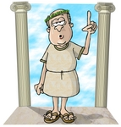

1) What political system was founded in Greece?

2) Where is Greece located?

3) Describe the three main portions of the Greek Stage.

4) What is the origin of the word “Tragedy”?

5) What elements did the dramas have? How were they performed?

6) What major Greek Dramatist wrote both Antigone and Oedipus?

7) What is the setting of Antigone?

8) Who are Antigone’s parents

9) Give 3 reasons why myths were developed.

10) Who is Dyonisus?

11) Where did hope come from?

12) Who lived on Mount Olympus?

13) Choose 3 of the female Greek goddesses and 3 of the male Greek gods and give 2 of their qualities.

