MLA Format Cheat Sheet

This handout provides a quick reference to the basics of using MLA style. For complete guidelines, consult MLA Handbook for Writers of Research Papers, 7th ed., call number: LB2369 .G53 2009.

Major Updates from the New (7th) Edition
- MLA no longer requires underlining. Titles, such as books and periodical titles, are now italicized rather than underlined.
- All entries in a reference list, whether print or electronic, must now include the medium in which they have been published (Print, Web, DVD, Television, etc.)
- URLs are no longer required in citations. MLA recommends that writers only include a web address if the audience is unlikely to find the source otherwise.
- New Abbreviations: Some sources do not have a date, publisher or pagination. MLA advises, where applicable, to write n.d. for no date, n.p. for no publisher, and n.pag. for no pagination given.

Formatting Basics
- Double space throughout paper, with no extra spaces between paragraphs.
- Do not right justify.
- Top, bottom, and side margins should be one inch.
- Indent the first word of each paragraph by ½ inch or 5 spaces.
- Do not use a title page for the research paper: instead simply type your name, instructor’s name, course number, and date. This should be flush with the left margin.
- Center the title of the paper. Do not underline the title, or put in “quotation marks,” or set in ALL CAPITALS.
- Number all pages consecutively in the upper right-hand corner, ½ inch from the top and flush with right margin. Type your last name before the page number, and do not use “p.” before the number.
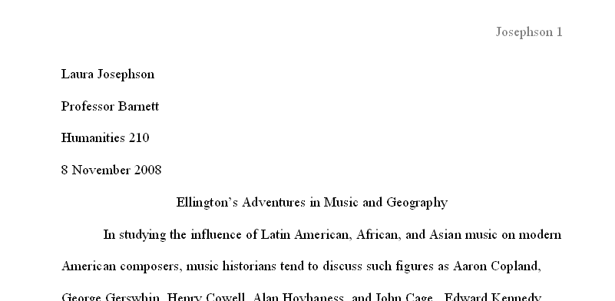

SAMPLE FIRST PAGE:

Works Cited

MLA style requires that the list of Works Cited start on a new page at the end of your paper. Formatting rules include:
- Continue page numbering from the body of your paper.
- Center the title “Works Cited,” one inch from the top.
- Alphabetize entries by the author’s last name. If no author, alphabetize by the title (ignore A, An,The).
- Use a hanging indent.

For books:
- Name(s) of authors or editors. If only citing one chapter within a book, the author and title (in “quotation marks”) of the chapter.
- Title of book (including subtitle) italicized.
- City of publication, name of the publisher, and year of publication.
- Medium of publication.
- Edition (only if 2nd ed. or later).
- Volume number (if there is one).
- If citing one chapter within a book, the page numbers of the chapter.

For print journal and magazine articles :
- Names of authors.
- Title of article in “quotation marks.”
- Title of journal or magazine italicized.
- Volume number (for a journal).
- Issue number (for a journal, if available).
- Date of publication (for journal article, note year only).
- Page numbers of the article.
- Medium of publication (Print).

For journal and magazine articles acquired using a library database:
- Names of authors.
- Title of article in “quotation marks.”
- Title of journal or magazine italicized.
- Volume number and issue number (for a journal).
- Date of publication (for journal article, note year only).
- Page numbers of the article as originally published in print journal.
- Name of the database italicized.
- Medium of publication (Web).
- Date of access (day, month, and year).

For websites:
- Name of author or editor (if given).
- Title of the work italicized if the work is independent; in quotation marks if it is part of a larger work.
- Title of the overall website italicized, if distinct from above.
- Publisher or sponsor of the site; if not available, use n.p.
- Date of publication (day, month, and year), if not available, use n.d.
- Medium of publication (Web).
- Date of access (day, month, and year).

Examples of Citations

Book with one author:
Steele, Timothy. The Color Wheel: Poems. Baltimore: Johns Hopkins UP, 1994. Print.

Book with two or three authors:
Broer, Lawrence R., and Gloria Holland. Hemingway and Women: Female Critics and the Female
Voice. Tuscaloosa: U of Alabama P, 2002. Print.

Book with four or more authors:
Jones, Terry, et al. Who Murdered Chaucer?: A Medieval Mystery. New York: Thomas Dunne Books,
2004. Print.

Chapter in a book:
Naremore, James. "Hitchcock at the Margins of Noir." Alfred Hitchcock: Centenary Essays.
Ed. Richard Allen and S. Ishii-Gonzales. London: BFI, 1999. 263-77. Print.
Translation:
Murasaki Shikibu. The Tale of Genji . Trans. Royall Tyler. New York: Viking, 2001. Print.
Print journal article:
Levine, June Perry. “Passage to the Odeon: Too Lean.” Literature Film Quarterly
14.3 (1986): 139-50. Print.

Journal article acquired using a library database:
Letemendia, V. C. “Revolution on Animal Farm: Orwell's Neglected Commentary.” Journal of Modern Literature 18.1 (1992): 127-37. JSTOR . Web. 6 July 2009.

Website:

Bio. A&E Television Networks, 2009. Web. 7 July 2009.

Newspaper article:
Daker, Susan. “No Happy Holiday for Refiners.” Wall Street Journal 3 July 2009: C10. Print.
Film:
Chocolat. Dir. Lasse Hallstrom. Perf. Alfred Molina and Juliette Binoche. 2000. Miramax, 2003. DVD.

Parenthetical Citations

- References in your paper must clearly point to specific sources in your list of Works Cited.
- In most cases, providing the author’s last name and the page number is sufficient:
Medieval Europe was a place both of “raids, pillages, slavery, and extortion” and of “traveling merchants, monetary exchange, towns if not cities, and active markets in grain” (Townsend 10).
- If you have several works by the same author, also include the title (abbreviated if long):
(Frye, Double Vision 85).
- If no author is listed, use the title (shortened if long):
Voice of the Shuttle has many electronic sources.
- If using the title, remember to use correct punctuation: italicize book titles, use quotation marks for journal articles, short stories, book chapters, etc.
- The author’s name can be referred to within the sentence:
Tannen has argued this point (178-85).
…or the author’s name can be referred to within the parenthetical reference:
This point has already been argued (Tannen 178-85).

For additional help
- Consult Joseph Gibaldi’s MLA Handbook for Writers of Research Papers, 7th ed,
available at the Reference Desk and on Reserve.
- Refer to the Online Writing Lab (OWL) at Purdue University: http://owl.english.purdue.edu/owl/resource/557/15/
- Utilize bibliographic management tools such as…
-RefWorks - https://www.refworks.com/Refworks
- Zotero (Firefox only) - http://www.zotero.org/
- Knight Cite - http://www.calvin.edu/library/knightcite/

