Maus PowerPoint Guide

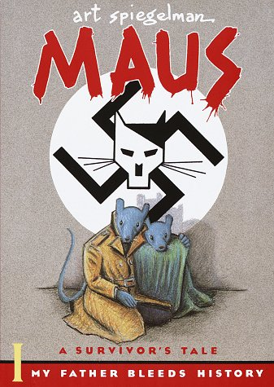
1) What is the difference between baring witness and telling a narrative?

2) Is Maus considered fiction or non-fiction? Explain your answer.

3) What must the reader do when reading a graphic novel, that one does not have to do with a book?

4) How does Spiegelman use animals in Maus?

5) Define: Anthropomorphize

6) Define: Dual Narrative

7) Why did the author choose the graphic novel form?

8) How is the mouse a visual metaphor? Explain Metonym.

