Media and Advertising PowerPoint Notes
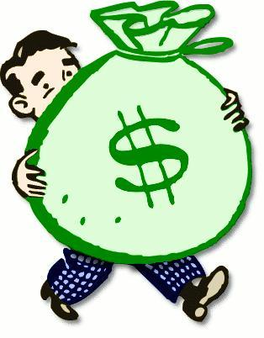
1) What is a promotion?

2) What is the purpose of product promotion?

3) What are the three elements of advertising?

4) What is the first step in making an advertisement?

5) Explain Step Two.

6) Explain Step Three.

7) Explain Step Four.

***MORE NOTES ON THE BACK***

Explain:

-Incentives and Promotions:

-Slogans

-Logos

-Beauty Appeal:

-Testimonial/Celebrity Endorsement:

-Escape:

-Lifestyle:

-Bandwagon:

-Rebel:

-Unfinished Comparison:

-FTC:

