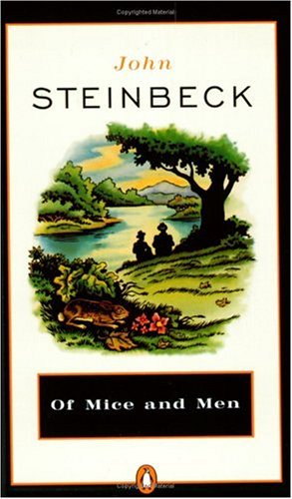PowerPoint Follow-Along Guide

1) Where was John Steinbeck born?

2) Name two of his best known novels.

3) Name three aspects of the Great Depression.

4) What was the New Deal? And who did not gain much from it?

5) What was the original title of Of Mice and Men?

6) What are your expectations for this book?

