# *Othello* Project Rubric

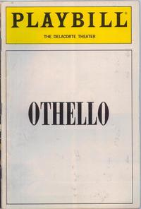

Names:

Act ____

Time of performance:

|  |  |  |  |  |
| --- | --- | --- | --- | --- |
|  | **Broadway bound!**  **10** | **Off Broadway quality**  **8** | **Summer Stock**    **6** | **Community Theater**  **4** |
| **Accuracy**  **x2** | Effectively and clearly conveys the most important elements of the act. | Conveys the most important elements of the act. | Misrepresents or omits some key element(s) of the play . | Events and characterization do not adequately reflect those from the play. |
| **Performance**  **X2** | Use of props appropriate that enhance performance;  Shows signs of rehearsal/ preparation. | Uses props;  Students appear prepared, familiar with material. | Some props are used but show little sign of effort; and/or students do not appear familiar with the material. | No props are used. Students do not seem at all prepared to present. |
| **Time**  **X1** | Between 4-5 minutes | Just over 5 or just under 4 minutes | Under 4 minutes or over 6 minutes | More than 7 minutes or 3 or less minutes |
| **Creativity (BONUS)**  **X1 (max 5 points)** |  |  |  |  |

___________/50