Parody Skit Assignment

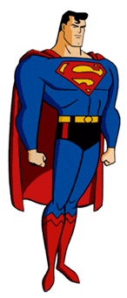

- Groups of three or four
- Create a skit in which you create a parody (pg 1015) about some type of epic hero.
- Examples: X-men, Superman, Batman, Star Wars, The Spartans, Hercules, Cat Woman, Any other epic hero that you can think of
- Individual participation grades will be given in addition to group grades therefore no SLEEPING, DOING OTHER WORK, or ANY OTHER OFF TASK BEHAVIOR
- Skits must be at least 10 min long
- There must be a script for ALL members of the group. The scripts must be:
-neatly typed up
-contain parts for ALL THREE or FOUR group members
-contain the elements of a parody (1015)

- You will have the end of today to brainstorm, all of tomorrow (Tuesday) to work, and performances will Wednesday

