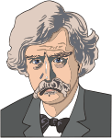 American Realism (1865-1910) Follow-Along Guide

1) What is the definition of Realism?

2) What major wars/historical events mark this period?

3) Name 5 characteristics of Realist characters.

4) Describe the tone of realist literature.

5) Name three principals of Realism.

6) List the 5 techniques used by Realist authors.

7) Who is Mark Twain?

8) Describe Realist art/Photography.

9) What is naturalism?

