The Crucible Theme Poster

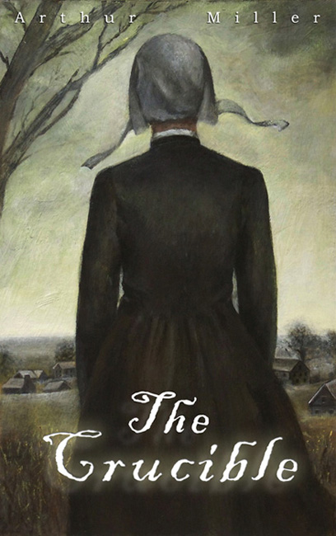

Your Poster Must Have:

- The name of your assigned theme at the top

- The PRIMARY character/Group/Pair that exhibits that theme

- 3 quotes from the novel that support your theme

- Some type of visual that corresponds to your theme

- On the back you must include a 4-6 sentence explanation of the character in relation to the theme

