The Rear Window Film Guide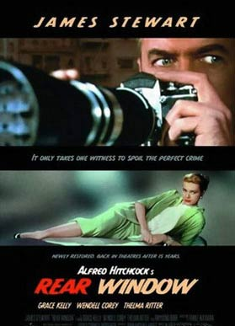
- Hitchcock has said that his "first instincts are to go with the visual and not follow the words." To what degree is this claim supported by Rear Window, and to what effect? What methods does Hitchcock find of providing (and deferring) exposition, of developing conflicts, and of resolving conflicts?

2. Describe as precisely as you can the relationship between Jeff and Lisa, both "prior to" the time of the film itself and during it. How is each of them characterized, and by what methods? When is it--exactly-- that Lisa finally becomes of interest to Jeff? What is it that motivates his interest?

3. In what ways does the exposition provided us about Jeff's career guide our analysis and evaluation of what he sees and imagines?

4. Did you feel a little bit like a voyeur (one who shamelessly spies
on others, often in their homes), when you were watching this movie?

5. Was Thorwald’s behavior really that suspicious?

6. Can “female intuition” really help solve crimes?

7. Are Jeff and Lisa a good couple?

8. What did you like and not like about this film?

