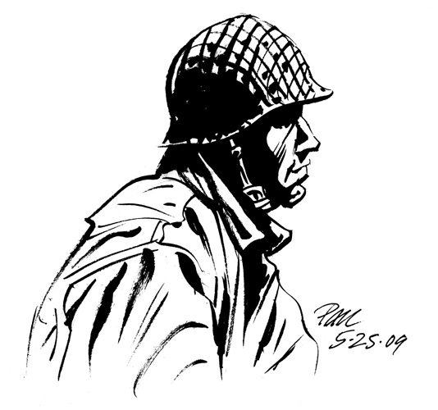
The Things They Carried Character Sketch

Directions: Choose one character from the story. You will create a sketch/ or drawing of this character including the following:

- 2 direct characterizations/quotes about the character

- 3 indirect characterizations/quotes about the character

- 2 symbols from the book that represent the character

- The name of the character

- A visual sketch of the character

- The page numbers next to all evidence found in the book

The Things They Carried Character Sketch

Directions: Choose one character from the story. You will create a sketch/ or drawing of this character including the following:

- 2 direct characterizations/quotes about the character

- 3 indirect characterizations/quotes about the character

- 2 symbols from the book that represent the character

- The name of the character

- A visual sketch of the character

- The page numbers next to all evidence found in the book

