The Crucible Unit: Reading an Image

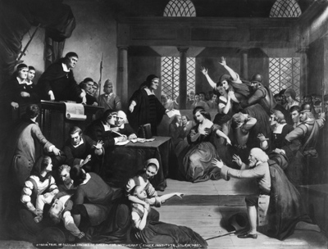
We are bombarded with images all day, every day and need to be aware of their unique influences on us. Today you are examining “The Trial of George Jacobs” to go along with our reading of The Crucible.

We will follow these steps as we read and respond to the image:
I. General Impression
On a separate sheet of notebook paper, write two or three sentences on your first impression of this piece of art. What is happening?

II. Examining Details
On this same sheet of notebook paper, create a three column chart and label it like the example below. One detail has been filled in for you to guide you as you fill in your own chart.

Who or what are you focusing on? | How is he/she/it positioned? | Why is he/she/it seen this way?
Man in red cape in foreground | On bended knee with hands outstretched towards the judges | He is pleading for his life

Choose five details (these may be persons or objects in the art) that seem significant to you. Complete the chart you have created using the above example for guidance.

Assignment:
You have now carefully examined portions of the art work. Now choose one person in the painting. You are to become that person and write at least a one page narrative from that person’s point of view. We should see what is happening through that character’s eyes and the reasons for your, as well as others’, motivations. Rely on the information you have learned about the Salem Witch Trials from your reading of Acts One-Three of The Crucible to help you as you tell your story.

Grading Criteria:

- I. Interpretation of the scene (mentions specific details that show understanding of the scene)
- II. Interpretation of the motivation of characters (mentions specific details that show insight into a character’s motivation)
- III. Prediction of what will happen after this scene (mentions details in the scene and applies knowledge of the play to make a plausible prediction)
- IV. Narrative is written in first person point of view and identifies the speaker
- V. Adherence to grammar, mechanics, and spelling conventions

