Introduction to American Realism
Mark Twain: His Amazing Adventure (Front and Back)
Directions: Answer the following questions while watching the film.
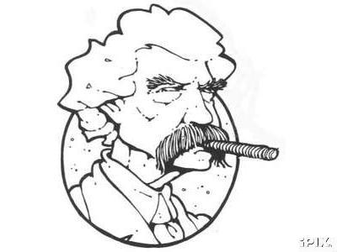
- How do you think Twain's boyhood days in Hannibal, Missouri influenced his adult life, especially his writings?

- How did Samuel Langhorne Clemens select Mark Twain as his pen name?

- Unfortunately, several personal and tragic events occurred during Twain's lifetime. What were some of these events, and what impact did they have on his life, professionally and emotionally?

- Twain lived through the U.S. Civil War. How did the war affect his life and work?

- Name four of Mark Twain's more well-known writings

6. The need to earn money to support his travels and lifestyle often altered Twain's life and travels. What are some examples of this?

7. What are some of the "ugly things" that Twain personally experienced or lived through during his lifetime? How did these change the way he wrote and behaved?

8. Twain is described and remembered as a "satirist." What does this phrase mean?

9. In this documentary, the narrator remarked that Mark Twain "had an understanding of life given to few men." What do you think this statement means?

10. Our next major literary period is American Realism. In two sentences, tell me what you think this will entail.

