Question 1: What familiar group of the sixties does this poster emulate? This is still an expression that we use today, why do you think it is so memorable? What is it’s message (besides the obvious)?

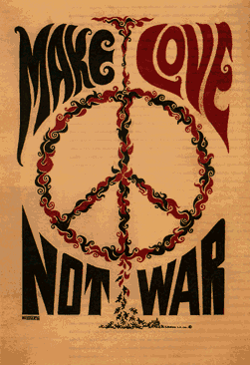

Question 2: This is a harsh political opinion on how the U.S. was conducting them self over in Vietnam. What is this poster saying about liberty and freedom? What emotions would it raise up if you were for or against the war?

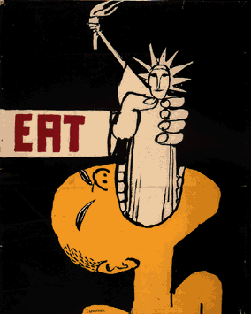

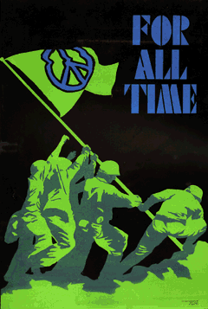
Question 3: This is one of the few where they use soldier imagery in a positive way to protest the war. According to the poster what should we be fighting for? There were those that argued that war the way to ensure peace by stopping communism. What would the makers of this poster say to that?
Question 4: The caption is translated as, “Fight the US enemy get out and puppet army lost.”
What message is this mean to send to the Vietnamese people? How does this compare with the other posters you viewed? What feelings might this poster incite in the Vietnamese people?

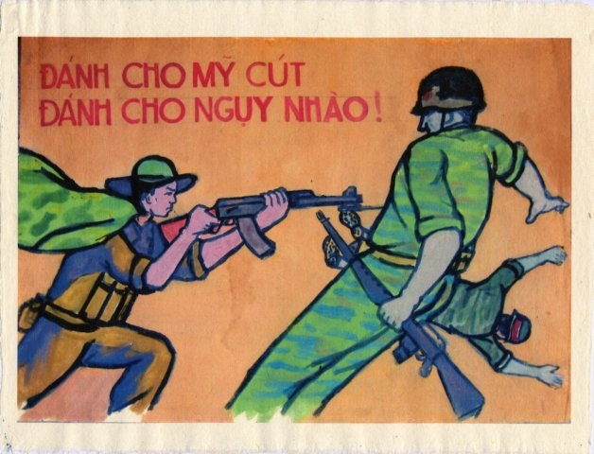

(Please answer poster questions on the back of this sheet. All questions must be completely answered to receive full credit
Effect in 1960’s | “Love” poster | “Eat” poster | “Peace” poster | Vietnamese poster
Effect of message today?

