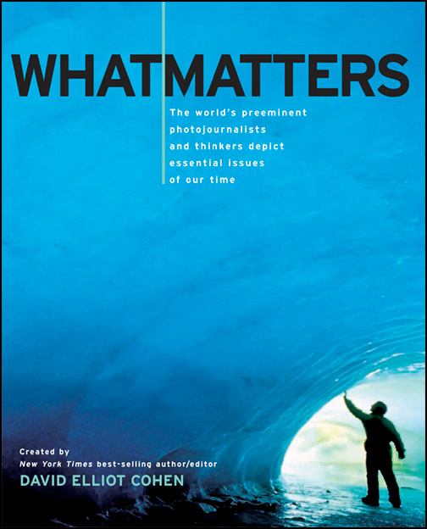
Spring 2010 Research Paper
Hayes/Schierholz
***This sheet is due Friday along with your Research Paper Contract sheet for a homework grade.***

Your task: You will soon be starting your senior research papers. What will you write about? To make this question easier to answer, you will be given the book, What Matters. This is a book that addresses many of the global issues that affect the world today. Your topic for your research paper MUST come from one of the chapters in the book. In order to assist in your brainstorming, you will be choosing THREE images and answering the following questions:

Image One:
-Title of Image:

-Page Number:

-Title of Chapter/Topic:

-Why did you choose this image? What draws you to this? Give a brief description of the image. (4-6 Sentences)

Image Two:
-Title of Image:

-Page Number:

-Title of Chapter/Topic:

-Why did you choose this image? What draws you to this? Give a brief description of the image. (4-6 Sentences)

(more on the back)

Image Three:
-Title of Image:

-Page Number:

-Title of Chapter/Topic:

-Why did you choose this image? What draws you to this? Give a brief description of the image. (4-6 Sentences)

Which image are you most likely to base your research paper on? Why? (4-6 Sentences)

Name/s of Students____________________________________________________

Decided Topic_______________________________________________________

