Lesson 7: Handout

Vietnam Southeast Asia

1964-1973

Over 58,000 Americans killed, 200,000 wounded and Women Were There!
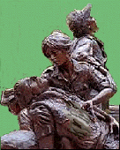
Over five hundred WACs were stationed in Vietnam.
Women Marines were in Vietnam.
Over six hundred Women in the Air Force were there.
Army, Navy and Air Force Nurses and Medical Specialists numbered over six thousand.
Untold numbers of Red Cross, Special Services, Civil Service and countless other women were there.
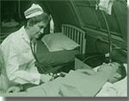
Da Nang, South Vietnam, 1968..United States Navy nurse Lieutenant Commander Joan Brouilette checks the condition of Pfc. Charles Smith as
she makes her daily rounds of the intensive care ward at the United States Naval Support Activity Hospital.
Women served in Vietnam in many support staff assignments, in hospitals, crewed on medical evacuation flights, with MASH Units, hospital ships, operations groups, information offices, service clubs, headquarters offices, and numerous other clerical, medical, intelligence and personnel positions.
There were women officers and enlisted women; there were youngsters in their early twenties with barely two years in service and career women over forty.
Women suffered the same hardships as the men in many cases and were often in the line of fire from rockets and mortars, particularly during the Tet offensive with the Viet Cong attacks on Saigon.
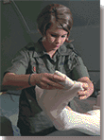
Vietnam. 1st Lt. Elaine H. Niggemann changes a surgical dressing at the 24th Evacuation Hospital.
Almost ten thousand women were there.
Women were awarded the Purple Heart, the Bronze Star,
Commendation Medals, and Unit Citations.
And yes there were casualties.
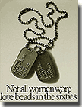
A total of 58,219 names appear on The Wall - as of May 1999.
All information was taken from http://userpages.aug.com/captbarb/femvetsnam.html

