1. “I never had anyone to sit with at lunch, but having cute shoes somehow made it seem not so bad.”

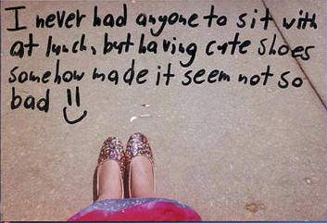

2. “I work as a nurse. The faces of some dead ex-patients are haunting me everyday. I am sorry I couldn’t save you.”

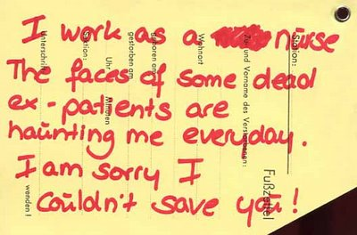

3. “If I had a choice, I’m not sure which I’d choose.”



4. “Every Saturday people take wedding pictures across the street from my apartment. My roommate and I stare out the window and judge the dresses.”

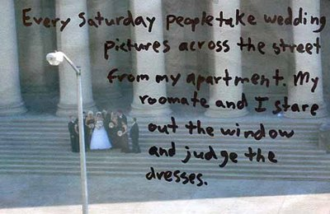

5. “Whenever a stranger stands by me, or passes, I wonder what’s on their mind, and when they walk away, I secretly miss them.”

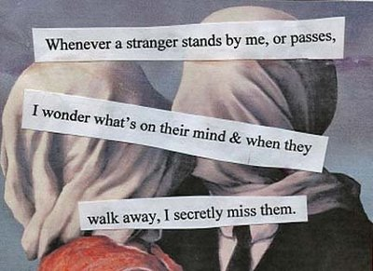

7. “I’m afraid to have a child for fear that he’ll be mentally handicapped like my brother is.”

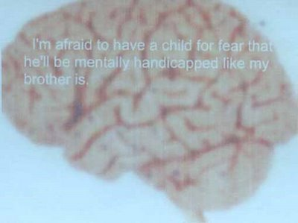

8. “The secret I mailed in last week was true when I wrote it. But it’s not anymore.”

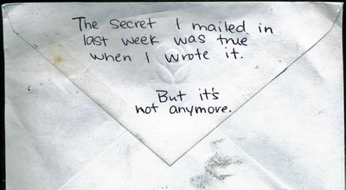

9. “Sometimes, when I go shopping, I ask to have my purchases gift wrapped, just so I can open them when I get home.”

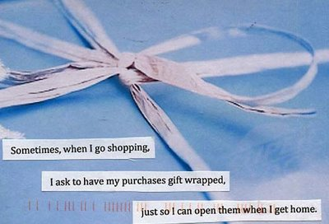

10. “You are loved. Someone slipped this note under my dorm room door last year and it made my day. Thank you, I needed to hear it.”

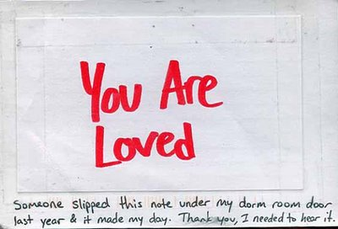

Girls, you are loved. No matter what you do, someone will always love you as much as you love yourself.

