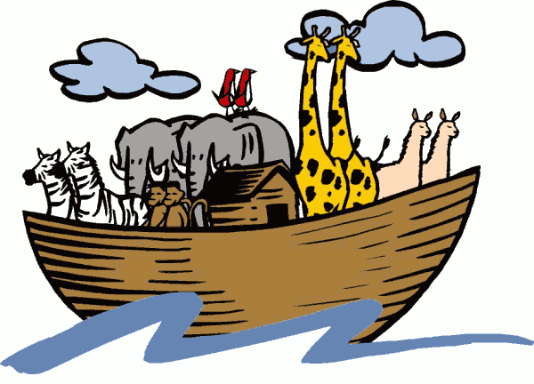Questions for “The Stoaway”

1) Who is the speaker in this story?

2) What was the journey like for the animals on the ark? How did the humans treat them?

3) According to the narrator, for how long did it rain during the voyage?

4) Explain the meaning of this passage: “Your species has always been hopeless about dates. I put it down to your quaint obsession with multiples of seven

5) List 5 main/specific/detailed examples of how this account of “Noah’s Ark” is much different from the commonly told version.

