Physical Science Guided Reading
NAME DATE PERIOD
Section 6.2 – Transferring Thermal Energy, pp. 164 – 170

- Explain how particle collisions between substances are necessary for the transfer of thermal energy in conduction and convection.

- What is the short rule describing convection?

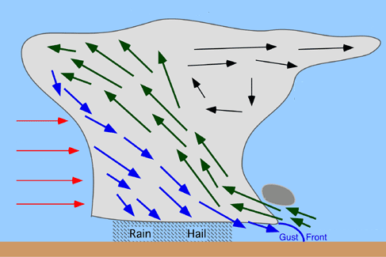
- Describe and draw the formation of a thunderstorm using these words:
warm, moist air expands and rises
cooler, drier air condenses and falls

- How does the Sun’s radiant energy heat the Earth?

- Expound how to calculate ΔT. Explain how ΔT can be negative.

- Explain how your mom’s advice to “dress in layers” will result in a greater insulation of your body.

- Desert dwelling people often dress with a dark cloak on the outside, a lighter cloak underneath that, and light tunic or shirt under that. Explain how these many layers of clothing actually helps keep them cool in the desert.
